# **Mid-Term Task**

## **Part I**

Steps:

1. Host a static website on Blob Storage: build and deploy a static Hello World website to Azure Storage.

2. Verify that the default web page has the **Hello World!** page.

3. Provide the steps and results.

**For starting this we need a resource group that we have to create in which we create a storage.**

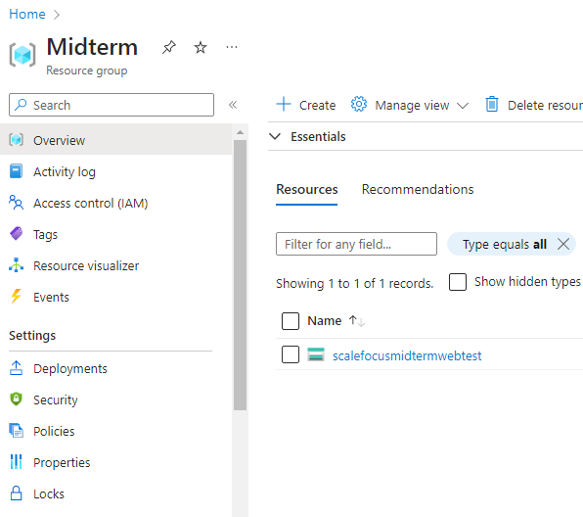

**In the storage, we choose Static Website and we Enable.**

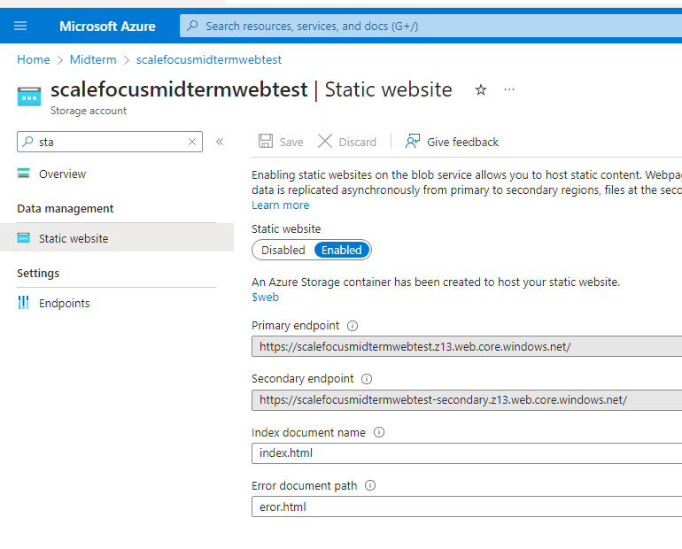

**In order to have Hello Word! Page, we need to upload the index.html file. To this we go to Containers and upload the html file into $web which is default I’ve also added a eror.html file.**

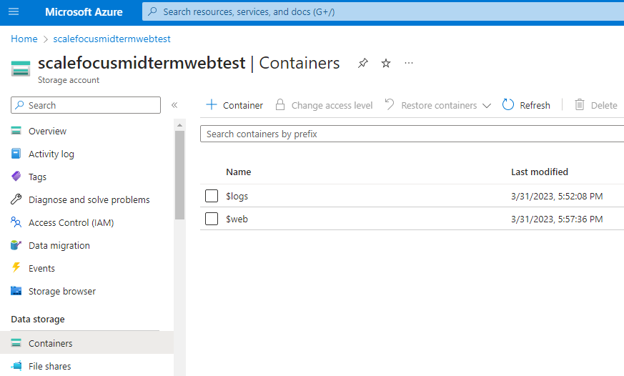

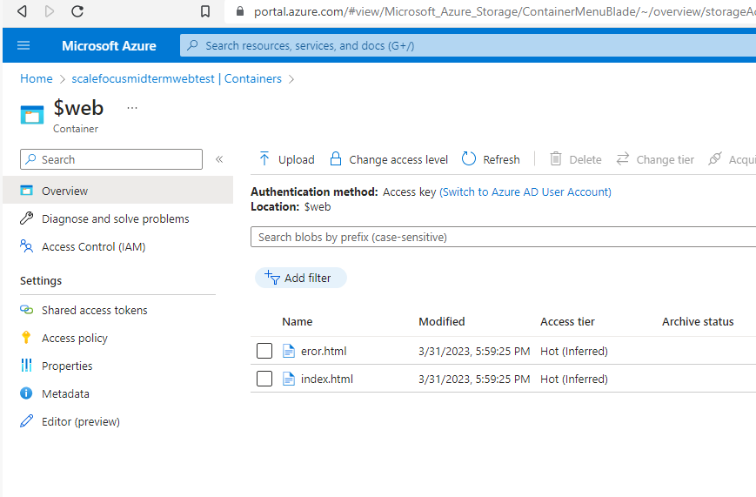

**The last step is to verify that the Static Web page is up and running so we just type the web URL and we are done.**

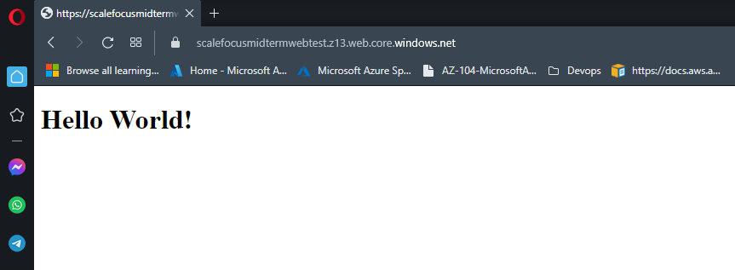

**Just to cover up the .html file I used visual studio to create a basic file with the following code:**

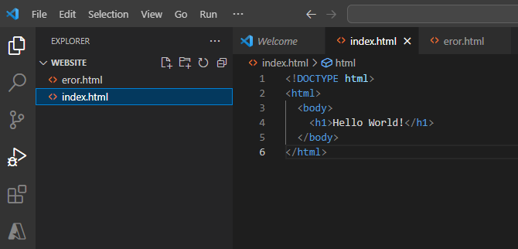

## **Part II**

In this exercise we will setup a Linux based web server and will

deploy a web page on it.

1. Create a Virtual Network where you will deploy your Linux Based

Web Server.

2. Modify the network security group for your virtual machine that will

allow you to remotely manage your machine only from your local

machine and nowhere else.

3. Create a Linux Virtual Machine that will be your Web Server which is

publicly available for web publishing (not SSL) only from your

machine and nowhere else.

4. Connect to the VM.

5. Install Apache Web Server.

6. Deploy the “Hello World” web page.

7. Provide Testing from your cellphone.

8. Provide the steps and results.

Steps:

**Create a VN I named mine Midterm_Part2.**

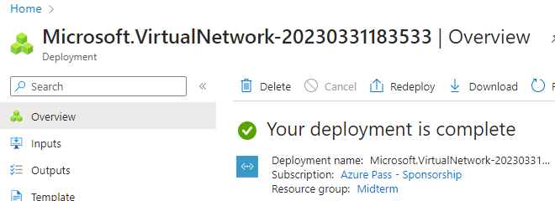

**Create a NSG, I misspelled the name I wanted MidtermNSG.**

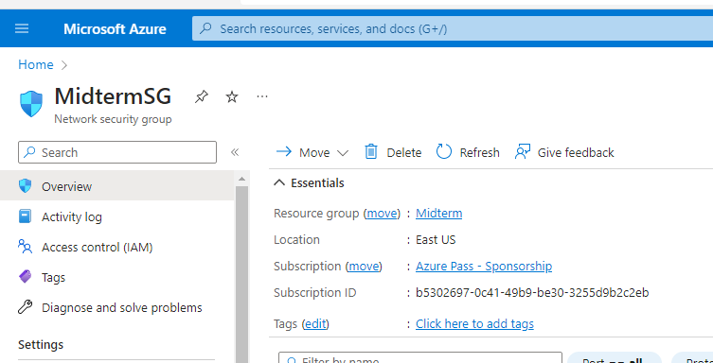

**I’ve created Linux VM :**

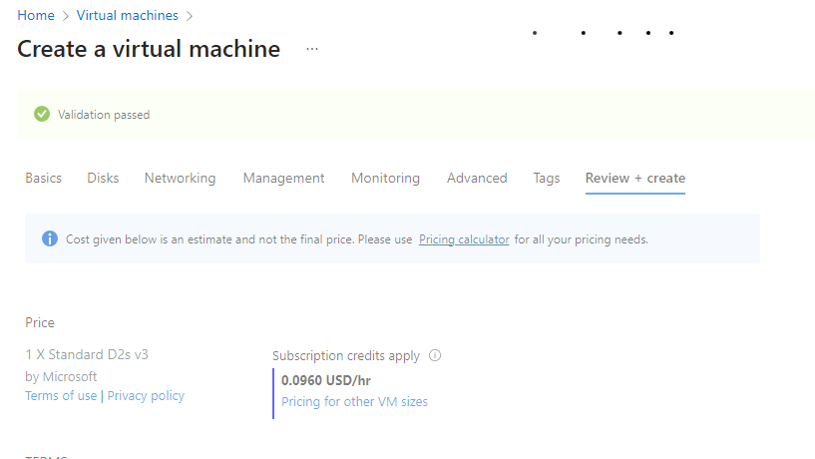

**I faced issues with connecting to the VM so a quick change in inbound rules.**

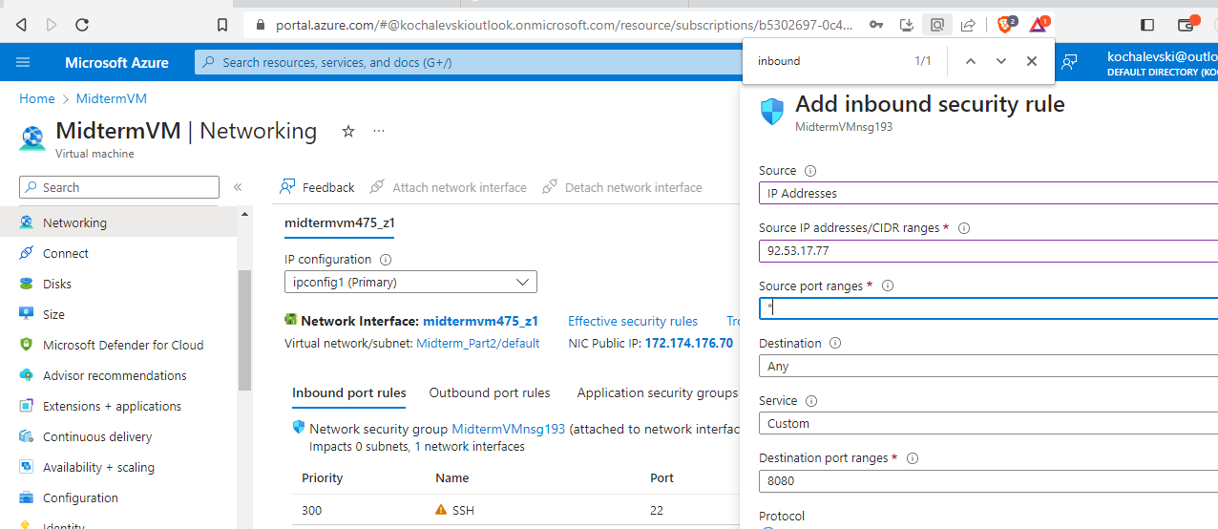

**And again I was not able do connect it. ☹**

**In the meantime to chillout I looked and defined the steps to install the apache:**

sudo apt-get install apache2

**With the public VM IP we can see if the Apache web server is running.**

**And in the nano editor we can again add the index.html file needed to have the Hello World! Message like on the Part 1**

**<!DOCTYPE html>**

**<html>**

**<body>**

**<h1>Hello World!</h1>**

**</body>**

**</html>**